ABQ Backyard Refuge Program
Certification Workbook
For more information and the full education guide,
plant list, and other useful resources,
please visit ABQbackyardrefuge.org

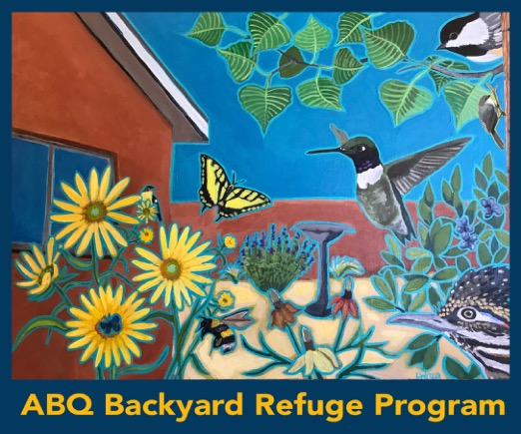

Certifying Your Backyard Refuge
An exciting component of the ABQ Backyard Refuge Program is the opportunity to certify your yard, patio, or balcony as an official ABQ Backyard Refuge, highlighting the important changes you are making in your personal space to support wildlife.
The ABQ Backyard Refuge certification process focuses on including in your space the elements of wildlife habitat that are specific and important to the Middle Rio Grande Valley. This certification aims to be inclusive to individuals and families regardless of the size of the space they are converting to wildlife habitat. Although building a backyard refuge is about creating native habitat in your own space, it is also about contributing to large-scale conservation efforts in our community.
One element of certification can be your engagement with habitat conservation and restoration projects throughout Albuquerque, which will be especially important if you do not have the physical space large enough to support all the components of healthy habitat all year long. Making small changes in small spaces can contribute to our community being more supportive of wildlife. Spreading the word about this opportunity and participating in larger-scale projects to support wildlife can make a huge difference for our community of wildlife and people.
Certification will be free or low cost based on your needs and provides the opportunity to certify and re-certify your space at multiple levels for years to come. We will provide participants with a certified ABQ Backyard Refuge sign for your yard or patio and a sticker indicating the year and level of certification you attained. We encourage you to re-certify your habitat each year with the goal of making positive changes for wildlife annually, and maybe even increasing your level of certification. Every year, we will have a new commemorative sticker for you to collect and put on your sign!
Certification Application
The ABQ Backyard Refuge Certification application will be accessed through the program’s website, ABQbackyardrefuge.org.
The application will be digital and will ask that you provide photos to supplement your answers showing how you achieve each certification parameter. Start taking photos of your progress to share when you apply for certification and for others in the program to see examples of ways to create a refuge for wildlife and people!

Certification Workbook
This workbook is designed to help you track progress towards certifying your ABQ Backyard Refuge, as a supplement to the educational resources and introductory guide on the program website. Each section of this workbook aligns with the different components of certification and helps you track and keep notes about your current practices or plans to achieve each required component of certification – food, water, shelter and space. You can also document your engagement in large-scale initiatives and use of sustainable practices. Use this workbook to track which level of certification you are currently achieving for each section or component of certification.
Take notes on habitat elements you would like to add to your space, or activities to engage in, to help you achieve your desired level of certification. Your detailed notes in this workbook will prepare you to demonstrate how you are achieving each certification parameter when you apply. As a reminder, it is good practice to take photos of your space as it transforms into a refuge. In your photos, focus on key habitat elements of your space and also document any wildlife your habitat to submit along with your ABQ Backyard Refuge Certification Application.

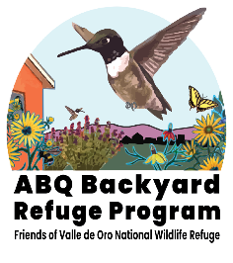
Three Levels of ABQ Backyard Refuge Certification
Contributing Habitat: Ideal for smaller spaces including patios, balconies or small courtyards. Focuses on providing some of the key elements of wildlife habitat while also working to engage in other larger-scale habitat conservation and restoration initiatives beyond your backyard.
Connector Habitat: Ideal for smaller yards, side-yards, or large deck spaces. Focuses on providing the basic elements of habitat including food, water, shelter and space for most of the year.
Core Habitat: Ideal for larger yards and community spaces where you can focus on providing a diversity of the key elements of habitat including food, water, shelter and space, to support wildlife during every season.
“in reshaping our thinking about dandelions or other so-called weeds, we might reshape our entire relationship with the living world” - Robin Wall Kimmerer

Food for Wildlife
Contributing Habitat Requirement: Provide at least 2 sources of wildlife-appropriate food.
Connector Habitat Requirement: Provide at least 4 sources of wildlife-appropriate food with at least 2 being native plants on the ABQ Backyard Refuge plant list.
Core Habitat Requirement: Provide at least 6 sources of wildlife-appropriate food during all 4 seasons with at least 4 food sources being native plants on the ABQ Backyard Refuge plant list.
NOTE: List a different plant for each food source category below. A single plant might provide several different types of food. For example, a cherry tree provides both fruit and pollen; it could be listed either as a “plant that provides fruits, berries, or nuts”, or as a “plant that provides pollen or nectar”. Ideally you could mix and match the plants in your space to fill each category and provide the required number of food sources for the level of certification you aim to achieve. The plants you use to achieve each category should be on the approved plant list found at ABQbackyardrefuge.org. To learn more about each of these plants and where they are found around the city, go to our iNaturalist guide: https://www.inaturalist.org/guides/13425
Leaves and twigs that provide food for wildlife
Plant Species and Description:

Seasonal Availability:

Plant(s) that provide pollen or nectar for wildlife
Plant Species and Description:

Seasonal Availability:

Plant(s) that provide seeds or pods for wildlife
Plant Species and Description:

Seasonal Availability:
Plant(s) that provide fruits, berries or nuts for wildlife
Plant Species and Description:

Seasonal Availability:

Supplemental feeders that provide seed, nectar, suet or nuts for wildlife
Feeder Types:

Seasonal Availability:

SEASONAL NOTES
List each food source you identified above in the applicable season it is available. Then check the box to indicate the seasons that you are providing food for wildlife:
□ Spring:
□ Summer:
□ Fall:
□ Winter:
DESIGN & CERTIFICATION NOTES
Level of certification currently met:
How and where might you add additional food sources to achieve a higher level of certification or diversify your habitat?
Water Source for Wildlife
Contributing Habitat Requirement: Not required.
Connector Habitat Requirement: One source of water for wildlife (including either a natural water source or installed water sources) available year-round or mix and match two sources of water available at different times of the year to support wildlife during at least three seasons.
Core Habitat Requirement: At least two sources of water (including a natural water source, or installed water sources) with both readily available to support wildlife during all four seasons.
Natural Water Source (within a quarter of a mile radius of a river, spring, arroyo or acequia)
Describe:

Seasonal Availability:

Installed Water Source
□ _Birdbath □ _Drip water system for wildlife
□ _Bowl of water □ _Puddling area for insects and small wildlife
□ _Other (Describe):

Seasonal Availability:

SEASONAL NOTES
A plan for how and when you will seasonally switch water sources to support wildlife during all four seasons:

DESIGN & CERTIFICATION NOTES
Level of certification currently met:
How and where you could incorporate new water sources in your space to achieve a higher level of certification or diversify your habitat?
Shelter (places to raise young or cover for wildlife)
Contributing Habitat Requirement: Not required
Connector Habitat Requirement: At least 2 sources of shelter or places for roosting to support wildlife during all four seasons.
Core Habitat Requirement At least 4 sources of shelter or places for roosting for supporting wildlife during all four seasons.
Shelter Areas
Describe the location of each shelter area in your space when you check each box.
□ Trees: □ Dense shrub or plant area:
□ Undisturbed native grass area: □ Ground cover:
□ Rock pile or rock/adobe wall: □ Bird house, bat box, bee/insect cubby:
□ Protected or built burrow: □ Host plants for insects:
□ Small brush or log pile (a distance from structures due to wildfire risk):
□ Snags (dead branches on trees): □ Other:

SEASONAL NOTES
A plan for how and when you will clean out wildlife boxes, provide different forms of shelter during different seasons, and trim trees and brush to avoid disturbing nesting or burrowing habitats of wildlife:

DESIGN & CERTIFICATION NOTES
Level of certification currently met:
How and where might you add additional sources of shelter or places for roosting to achieve a higher level of certification or diversify your habitat?
Best Practices
Contributing Habitat Requirement: 2 practices from any section in the list.
Connector Habitat Requirement: 3 practices from any section in the list.
Core Habitat Requirement: 6 practices from any section in the list.
You can meet this requirement by achieving 2-6 practices across all categories (Soil and Water Conservation, Wildlife Gardening Practices, and Engagement), so feel free to pick and choose the practices you are achieving or supporting between the different categories.
Soil and Water Conservation
□ Capture rainwater from roof and move overflow water to landscaped areas using a swale, basin, or other method of diversion e.g., a hose attached to a rain barrel.
Describe:
□ Have xeriscape elements (water-wise landscaping)
Describe:
□ Use drip or soaker hose for irrigation
Estimated length of system and locations:
□ Limiting water use
Describe:
□ Reducing erosion
Describe:
□ Use mulch to keep soil cool and help maintain soil moisture
Estimated percentage of space with mulch:
□ Make and use compost where plants need it
Describe composting method:
□ Scoop the poop in your yard and on walks!
Wildlife Gardening Practices
□ Keep pets indoors or in controlled areas
Describe method of control:

□ Convert traditional lawn from one species to a diversity of native and drought-tolerant plants
List plant species or seed mix:

□ Add native and drought-tolerant plants to supplement or replace existing vegetation in your yard.
Describe amount and types of plants:

□ Prune after insect emergence in spring plants and before nesting season begins
Months you will prune:

□ Trim trees and plants after wildlife nesting seasons, leaving some dead branches when possible for wildlife
Months you will trim:

□ Leave leaf litter for over-wintering wildlife
Describe:

□ Eliminate chemical pesticides/herbicides/rodenticides and practice non-toxic methods of Integrated Pest Management
List alternatives methods used:

□ Eliminate chemical fertilizers
List alternatives methods used:
□ Allow plants to flower and go to seed
Describe/plants or areas of space allowed to flower and seed:

□ Leave some fruit on fruiting trees for wildlife
Describe fruits provided to wildlife:

□ Leave bare ground for ground-nesting bees
Estimated percentage of space left bare (without weed cloth):
Best Practices...
Engagement
□ Post wildlife or plant observations on citizen science website
(Examples: iNaturalist, eBird, Nature’s Notebook, etc.)
Citizen science sites or programs:

□ Advocate for land conservation
Describe your advocacy actions:

□ Volunteer at public lands or with environmental conservation organizations
Locations of service and estimated hours volunteered each year:

Organizations/Site:
Volunteer hours per year:
Main volunteer tasks:

Organizations/Site:
Volunteer hours per year:
Main volunteer tasks:

Organizations/Site:
Volunteer hours per year:
Main volunteer tasks:

□ Attend an ABQ Backyard Refuge or program partner event or training
Name and date of event/training:
Takeaways:
Name and date of event/training:
Takeaways:
Name and date of event/training:
Takeaways:
□ Promote the ABQ Backyard Refuge Program at community gatherings or on social media
Community promotion / social media site and date:
Promotion details:

Community promotion / social media site and date:
Promotion details:

Community promotion / social media site and date:
Promotion details:

□ Recruit neighbors, friends and/or family to seek ABQ Backyard Refuge Certification
Keep a running list of individuals or families you recruited to help you keep track.
Number of families engaging in the ABQ Backyard Refuge Program due to your efforts: _______
Name, Recruitment date:
Name, Recruitment date:
Name, Recruitment date:
Name, Recruitment date:
Name, Recruitment date:

CERTIFICATION NOTES
Level of certification currently met:
How and where you might practice additional best practices to achieve a higher level of certification?
ABQ Backyard Refuge Design
Although not required for certification, we encourage you to map out the space you are enhancing or converting to wildlife habitat regardless of whether it is a balcony, patio, yard, or large acreage. By plotting out your space, you can more easily decide on elements to add based on size and the mature growth of the plant species, which is indicated in the ABQ Backyard Refuge Plant List. The plants you use to achieve each category should be on this list. To learn more about each of these plants and where they are found around our area, go to our iNaturalist guide: https://www.inaturalist.org/guides/13425
By creating a comprehensive design, you can set goals for yourself and the garden you want to create including who (what kind of wildlife) you are trying to attract, when (time of year) that wildlife will be in our community and what part of their needs your space will meet. Then match your goals with your resources. Smaller spaces should be carefully planned. Container gardens in tight spaces can still provide important habitat for a variety of wildlife while allowing you to experiment without much investment. If you are converting a smaller space, be strategic and look at the gardens around you to see how you can tie your planting into the larger landscape of your neighborhood rather than trying to fit everything to support wildlife in a smaller space. This is a great opportunity to recruit your neighbors to create a diverse mosaic of wildlife habitat throughout your community, rather than just in your yard or space.
Another thing to consider is that existing plants in your yard may already be providing important habitat benefits. Before beginning to make substantial changes, watch and listen for activity in your yard. If you find wildlife using certain areas and plants, consider working to improve habitat around those areas. A dense non-native shrub or mature tree may be providing shelter and habitat benefits that a new plant could take years to replace. While you may need to remove an established non-native or water-intensive plant, consider waiting until your new plants are well established and able to that habitat benefit.
Plotting Your Space
Creating a scaled drawing of your space is helpful to visualize, plan and build your ABQ Backyard Refuge. Imagine this task as making a roadmap; just as a roadmap has an appropriate scale, choosing the best scale for your space is important for drawing in plants and other features at their mature sizes to avoid overplanting and overcrowding.
• To plot or create a drawing of the space you wish to convert to an ABQ Backyard Refuge, use the gridlined sheet below or own graph paper. In the sheet we provide, the major, darker gridlines are spaced 1” apart and divided with lighter lines to create 100 blocks per square inch.
• In order to determine an appropriate scale for your drawing, you will need to know the outside dimensions of the space you want to convert or modify. Be sure to use a measuring tool to get an accurate reading of your space rather than estimating the size.
• If your area measures 70 ft x 50 ft, or similar dimensions, use a scale of 1 inch equals 5 foot (so a single darker square on the gridded paper is 5 ft x 5 ft and a group of four darker squares on the grid equals 100 square feet).
• If your space is smaller, use a scale that maximizes the size of the drawing on the grid. You might use the scale of 1 inch equals 1 foot (so each darker square on the grid equals 10 square feet).
• If your area is fairly large, it can be difficult to label details legibly, therefore you may want to break your space into separate, more manageable areas and use multiple sheets of gridded paper.
Now, plot your space using your chosen dimensions. Use a pencil so you can erase or make changes.
• Measure the positions…
• Measure the outer perimeter of the space you are designing and plot it on the gridded sheet. Be sure to use a measuring tool to get an accurate reading rather than estimating the size of your space.
• Measure the positions of any features that will be part of the ABQ Backyard Refuge and plot them on your base plan: existing trees and shrubs; the walls and windows and doors of the house that face the space; existing patios and walkways, etc.
• Make note of any features that may be removed to accommodate the new design.
Although you may eventually want to turn your whole yard into habitat, feel free to only plot the space you will start converting, knowing you can plot out your space again in the future if you want to add to your habitat area. This allows you to start with a more manageable, strategic and meaningful space.
Take photos of the area from several angles (including the view from adjacent windows) to use as a reference. This helps put the space into context, remind you of existing features you need to work around, and document your starting point.
Creating Your Design
• Start with drainage and grading, identifying where water is available and how to move it to planted areas using water management or improved landscaping techniques.
• Organize space around rainwater harvesting opportunities to support existing large or water-intensive plants or space for a future tree or plant that will require extra water.
• Identify space for pathways that will divide larger spaces into smaller planting areas.
• Indicate any area available to layer stones against a wall to create more space for wildlife and a unique planting area. Desert plants will grow well in between rocks.
• Be sure to leave open space or bare ground for native bees or seating areas for wildlife viewing while in the landscape.
• Consider the location of windows to design areas for winter wildlife-viewing opportunities.
• Consider what you value in a yard or garden space and design for your values first, then take note of the habitat value. After all, you are designing a refuge for you and your family as well as wildlife. Be sure to leave space for play and engaging in your space. Be sure to leave room for play and engaging in your space.
• Place the largest plants and trees on the plan first, which will help determine light availability for adjacent plants and water shared between them.
• Think about building habitat from the ground-up and sky-down. The more layers you build the more diversity you create to support more wildlife through more seasons.
• Plan for seasonal abundance. Early spring-blooming plants can be paired with a summer-blooming plant. 14
• Clustering and massing plants in groups is especially effective for supporting pollinators. Aim for 5 to 7 clusters of wildflowers or grasses planted together, spaced far enough apart so each plant can grow well (see mature sizes noted in the plant list.)
• Take note of sun availability in your planting spaces during different seasons to help choose appropriate plants with different light requirements.
• Create separate zone areas in your design specifically for native plants, which require less water / intermittent deep watering, and non-native plants, which usually require more water more frequently. That way you can more effectively satisfy the water requirements for a zone rather than plant by plant.
• Remember, you will not get things 100% right the first time around, and you may need to redesign areas of your space after each season to work better for your goals, but part of the fun of developing habitat are the lessons learned. Sometimes things may not work as you planned, but the result may be just as successful at attracting wildlife, and interesting to look at.
• Flexibility is key knowing this is a space you will continue to work on and play in.
• You will better enjoy your space and the process of designing a refuge if you learn to become a partner with nature, rather than trying to control it.
• Some plants may not do well where you thought they would, so be flexible and learn from each season. Remember that well-adapted plants grow roots before they develop new top growth, so give plants time to establish themselves.
• At the beginning, experiment with a variety of plants and build on what flourishes in different planting areas.
• Spend time in your yard watching and listening for wildlife and look for ways you can support them while attracting more wild neighbors.
• Take notes of necessary changes for future years and refine your design each year.

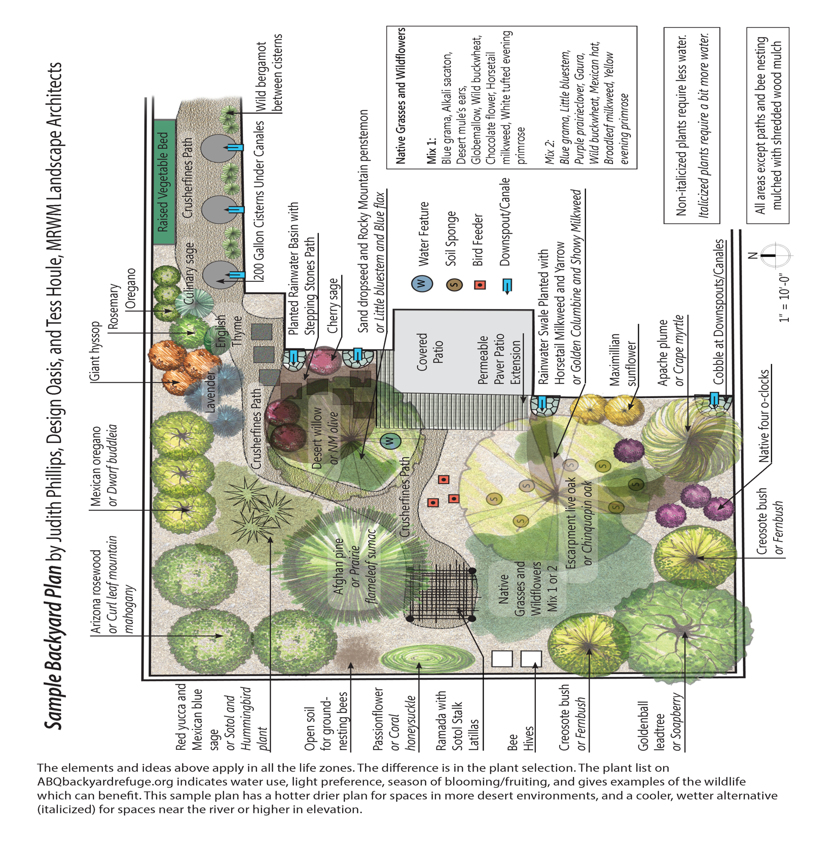

Certification Form Questions - Habitat Elements and Engagement
Fill out this section completely using your answers on the section beginning on page 4 in the workbook before going to ABQbackyardrefuge.org and beginning the online certification form.
What type of space(s) are you aiming to certify as an ABQ Backyard Refuge? (Check all that apply)
□ Front Yard □ Back Yard □ Side Yard □ Patio, Deck or Courtyard □ Balcony
□ Community Space Open to the Public □ Private Community Space (apt complex rooftop or courtyard)
□ Property of a Business/Organization □ Other
Details or notes about type of space(s) you are aiming to certify as an ABQ Backyard Refuge:

Certification Level - use the section starting on page 4 of this workbook to determine the highest level of certification you meet in all categories: □ Contributing □ Connecting □ Core Habitat

Food for Wildlife (workbook pages 4-5): How many native plant food sources does your space provide? (Include only plants from the ABQ Backyard Refuge plant list that provide pollen, nectar, seeds, fruits, nuts, etc.). Select: 0 - 6 or more
How many supplemental feeders does your space provide (bird feeder etc.)? Select: 0-4 or more

Total number of wildlife-appropriate food sources your space provides? _____

Which seasons do you provide wildlife-appropriate food in your space? (At least 1 supplemental feeder or native plant food source must be available for each season you indicate)
□ Spring □ Summer □ Fall □ Winter
Details or notes about wildlife-appropriate food sources your space provides:

Water for Wildlife
How many water sources for wildlife (including either an installed water source or natural water source within a quarter of a mile radius of your property) does your space provide? Select: 0 - 2 or more
Which seasons do you provide at least one water source for wildlife (installed or natural) in your space?
□ Spring □ Summer □ Fall □ Winter □ I do not provide a water source
Do you provide two sources of water for wildlife (installed or natural) during all four seasons in your space? (required for Core Habitat level) (Y/N)
Details or notes about water sources your space provides:
Shelter for Wildlife
How many sources of shelter or places for roosting are available to support wildlife during all four seasons in your space? _____
Details or notes about sources of shelter for wildlife or places for roosting in your space:

Best Practices
How many soil and water conservation best practices does your space achieve? ____
Details or notes about soil and water conservation best practices your space achieves:

How many wildlife gardening best practices does your space achieve? _____
Details or notes about wildlife gardening best practices your space achieves:

How many engagement best practices have you achieved while working on your space? _____
Details or notes about the engagement best practices you have achieved while working on your space.

Total number of best practices you have implemented? _____
(Add up numbers in the Best Practice sections above)

