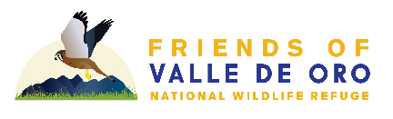

Supporter Commitment Form
2022 Online Auction - October 30 through November 6, 2022

Benefitting
Friends of Valle de Oro National Wildlife Refuge

A 501(c)3 Non-profit Organization, Tax ID: 46-2102958

We are once again holding our Online Auction, our largest annual fundraiser.

Please complete the following information, then email or mail this form to the Friends of Valle de Oro NWR, 7851 2nd Street SW, Albuquerque, NM 87105. Checks should be made payable to the ‘Friends of Valle de Oro NWR’ and indicate in the memo that it is in support of the Annual Fundraiser. Please also send a high-resolution logo, via email, to auction@friendsofvalledeoro.org as soon as possible for promotional purposes.

For more information, contact David Barber at 505-400-4381 or david@friendsofvalledeoro.org

Name Company Address City State Zip Phone# Fax E-Mail

Yes, I will support the Friends of Valle de Oro National Wildlife Refuges 2022 Annual Fundraiser.
$10,000 and Above - Kestrel Supporter Level – Amount $
$5,000 - $9,999 – Coyote Supporter Level – Amount $
$2,500 - $4,999 – Roadrunner Supporter Level – Amount $
$1,000 - $2,499 – Prairie Dog Supporter Level – Amount $
$500 - $999 – Whiptail Lizard Supporter Level – Amount $
Up to $500 & In-kind – Butterfly Supporter Level – Amount $
Other Amount $

Check Payment:
My Check # is enclosed for $ .

Charge my credit card:
Name on Card Card # Exp.

CVV Signature
7851 2ND ST SW, Albuquerque New Mexico 87105 www.friendsofvalledeoro.org

